Module 8:

Reviewing and Finalizing the Schedule

Contents

Module Overview 1

Lesson 1: Working with Groups and Filters 2

What are Groups? 3

How to Use Groups 5

What are Filters? 8

How to Use Filters 12

Practice: Working with Groups and Filters 18

Lesson 2: Understanding the Critical Path Method 19

What is a Critical Path 20

Formatting Views to Display Critical Path 22

Setting Slack Tolerance 26

Crashing the Critical Path 29

Practice: Working with the Critical Path 32

Lesson 3: Setting a Project Baseline 33

What is a Baseline? 34

Fields Involved in Setting a Baseline 35

Setting the Baseline 37

Updating a Baseline 41

Views Using Baseline Data 43

Practice: Setting a Project Baseline 48

Summary 49

8

.

# Module Overview



Once a schedule has been created, it is beneficial to look at the data from different points of view. Project 2010 has the ability to group and filter schedule data to allow for flexibility that will be needed for various reports. While the schedule is being built, a timeline is being built as well but the scheduler should determine if the timeline is correct. Once the timeline has been finalized, setting the baseline will lock down the original schedule.

In this module you will learn about:

1. Filtering and grouping schedule data
2. Examining the critical path
3. Setting the schedule baseline

# Lesson 1: Working with Groups and Filters



The data in a Project 2010 schedule file can be manipulated to allow viewing data from alternate points of perspectives. Data criteria are entered as a request and data is extracted as a result of the query. When the criteria parameters are removed, the data will return to the original status for the schedule. Groups and filters may be applied to the same table simultaneously to refine the data required for reports.

This lesson examines:

1. What are groups
2. How to use groups
3. What are filters
4. How to use filters

**NOTE:** *Project 2010 has the ability to create customized groups and filters. This lesson will be addressing software groups and filters that are part of the standard software install. Customized groups and filters are discussed in Appendix A.*

## What are Groups?



Grouping data allows different ways of looking at the schedule data to help solve problems and answer questions. In a large schedule, grouping becomes a very valuable tool to group data from all task levels based on values within the schedule itself. Groups are created based on the value in a column and viewed through a table or a view. A column does not have to be contained in a table to be used as grouping criteria.

Criteria for Groups are provided for task, assignment and resource groupings and are not interchangeable. Only task groupings may be applied to task views, resource groupings to resource views and assignment groupings to assignment views.

Task Groups provided are:

|  |  |
| --- | --- |
| **Group name** | **Grouped by criteria**  **(column name)** |
| Active vs. Inactive | Active |
| Auto scheduled vs. Manually scheduled | Task Mode |
| Complete vs. Incomplete | % Complete |
| Constraint Type | Constraint Type |
| Critical | Critical |
| Duration | Duration |
| Duration then Priority | Duration, Priority |
| Milestone | Milestone |
| Priority | Priority |
| Priority keeping outline structure | Project, Outline number, Priority |
| Resource | Resource Name |
| Status | Status |

Resource Groups provided are:

|  |  |
| --- | --- |
| **Group name** | **Grouped by criteria**  **(column name)** |
| Complete and Incomplete Resources | % Work Complete |
| Resource Group | Group |
| Resource Type | Type |
| Standard Rate | Standard Rate |
| Work vs. Material | Type |

Assignment Groups provided are:

|  |  |  |
| --- | --- | --- |
| **Group Name** | **Grouped by criteria**  **(column name)** | **Comments** |
| Assignments keeping outline structure | Name, Task outline number | May only be used from Resource Usage view |

NOTE; *Creating custom groupings are described in Apprendix A.*

## How to Use Groups



**To apply a Task grouping:**

* Reveal a Task based view or table
* **View** 🡪 **Group by** in the Data section
* Select the required grouping   
    
  Standard groups are highlighted below:

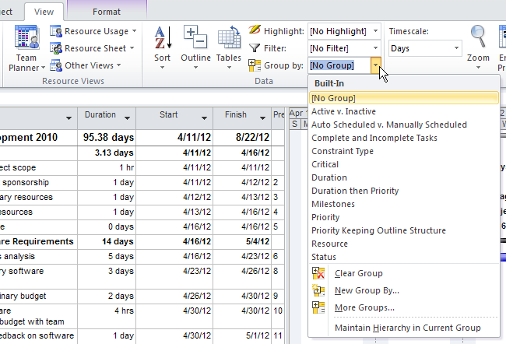

In the example below, the Duration grouping has been applied to the Task Entry table. The group intervals are described at the top of each grouping. Clicking the small box highlighted below to the left of each grouping level title will allow for collapsing and expanding the grouping levels. The view below has the groups expanded to reveal all detail.

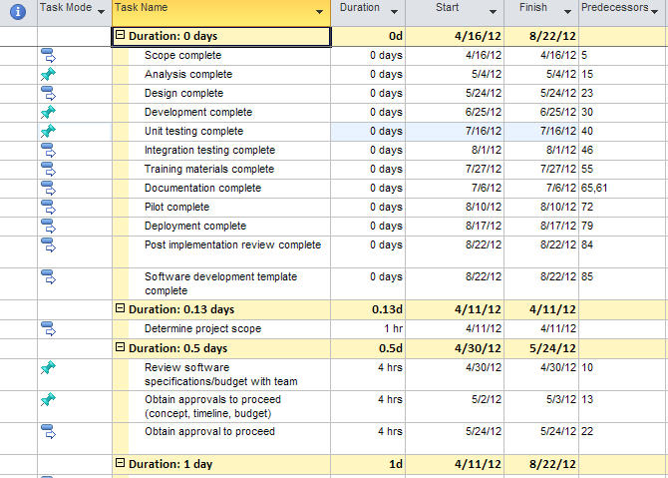

To collapse the groupings of data to obtain totals:

* **View** 🡪 **Outline** 🡪 **Level 1**

The collapsed view is shown below. Click the plus signs to view details within a group.

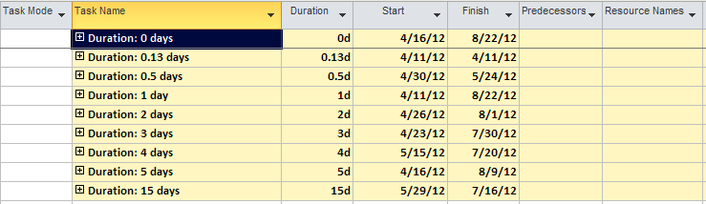

To restore all groupings to full detail.

* **View** 🡪 **Outline** 🡪 **All Subtasks**

To remove a grouping:

* **View** 🡪 **Group** 🡪**No Group** or **Clear Groups**

Grouped reports may be printed.

**NOTE:**  *Groupings have the ability to be grouped using a maximum of 10 grouping values.*

## What are Filters?



Filters allow the scheduler to request specific data using a column value for filter critiera. Filtered data allows focusing on data that is required for a specific report or query. The column data used to filter a report does not have to be contained in the current view or table. Some filters will request data at the time they are executed to obtain run time values. Filters may also be applied to Project 2010 standard reports and used for data exports as well.

Project 2010 provides preset filters for task, assignment and resource data. Custom filters may also be created and will be addressed in Appendix A. The Autofilter, which is also a feature in Excel, is available in Project and may be used independently as a filter or in addition to other applied filters.

Filters are created as task filters or resource filters. Below is a list of the standard filters that are part of Project 2010.

Task filters provided are:

|  |  |  |
| --- | --- | --- |
| **Filter** | **Criteria to filter on is contained in field** | **Requires value entered at run time** |
| Active Tasks | Active |  |
| Automatic scheduled tasks | Task Mode |  |
| Completed Tasks | % complete |  |
| Costs Greater Than… | Cost | X |
| Cost Overbudget | Cost v Baseline cost |  |
| Created After… | Created | X |
| Critical | Critical |  |
| Date Range… | Start, Finish | X |
| In Progress Tasks | Actual start, Actual finish |  |
| Incomplete tasks | % complete, % work complete for the assignment |  |
| Late tasks | Status |  |
| Late/Overbudget Tasks Assigned To… | Resource Name, baseline finish, Finish v Baseline finish, Cost v Baseline cost | X |
| Linked fields | Linked fields |  |
| Manually Scheduled Tasks | Task Mode |  |
| Milestones | Milestone |  |
| Resource Groups… | Resource Groups | X |
| Should Start By… | Start v Actual Start | X |
| Slipped/ Late Tasks | Baseline Finish, Finish v baseline finish, BCWS v BCWP |  |
| Slipping Tasks | Actual finish, Baseline finish, Finish v Baseline finish |  |
| Summary tasks | Summary |  |
| Task range… | ID (range of task ID numbers) | X |
| Tasks with a Task Calendar Assigned | Task Calendar |  |
| Tasks with Attachments | Objects, Notes |  |
| Tasks with Deadlines | Deadline |  |
| Tasks with estimated Durations | Estimated |  |
| Tasks with Fixed Dates | Constraint type, actual start |  |
| Tasks without Dates | Start, Finish |  |
| Tasks/Assignments with Overtime | Overtime Work |  |
| Top level tasks | Outline level |  |
| Unstarted tasks | Actual Start |  |
| Using Resource In Date Range… | Resource name, Start, Finish | X |
| Using Resource… | Resource Name | X |
| Work overbudget | Actual Work vs. Baseline Work |  |

Resource filters provided are:

|  |  |  |
| --- | --- | --- |
| Filter | Criteria contained in field | Requires value entered at run time |
| Budget Resources | Budget |  |
| Costs Greater Than… | Cost | X |
| Cost Overbudget | Cost v Baseline cost |  |
| Created After… | Created | X |
| Date Range… | Start, Finish | X |
| Group… | Group | X |
| In Progress Assignments | Actual start, Actual finish |  |
| Linked Fields | Linked fields |  |
| Non-budget Resources | Budget |  |
| Overallocated Resources | Overallocated, Assignment |  |
| Resource Range… | ID | X |
| Resource - Cost… | Type | X |
| Resource - Material | Type |  |
| Resource - Work | Type |  |
| Resources With Attachments | Objects, Notes |  |
| Resource/Assignments With Overtime | Overtime Work |  |
| Should Start By… | Assignments, Actual Start | X |
| Should Start/Finish by... | Start, Finish | X |
| Slipped/Late Progress | Baseline finish, Finish, WCWS |  |
| Slipping Assignments | Actual finish, Baseline finish, Finish |  |
| Unstarted Assignments | Actual start |  |
| Work Complete | % complete |  |
| Work Incomplete | % complete, Work |  |
| Work Overbudget | Work v Baseline Work |  |

## How to Use Filters



To apply a Task filter from the Gantt Chart View:

* **Task 🡪 Gantt Chart**
* **View 🡪 Filter 🡪 Select Filter**

The list of filters shown is a short list of standard available task filters.

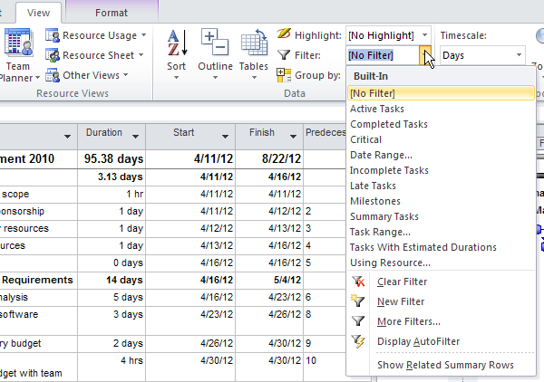

In the example below, the task Milestone filter has been applied. The filter contains the critieria to filter out and show only the detail tasks that contain a value of “Yes” in the Milestone column. The filter defination also indicates that the summary tasks should be included in the view. Milestone reports are very good project status reports because they hide all of the project detail and display the goal points of the project.

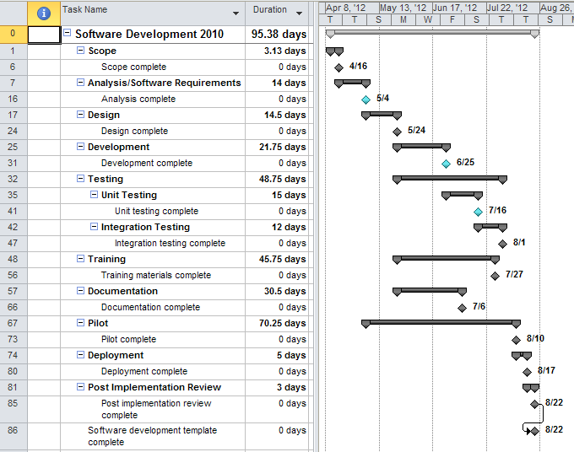

To remove the filter:

* Click **View 🡪 Filter 🡪 No filter or Clear Filter**OR
* Click **F3**

More filters are available by clicking **More Filters** at the bottom of the available filter list. When this option is selected, the box below will appear. In the More Filters dialog box below, there are options to select either Task or Resource filters. The list of available filters for each will be different because the filters are designed to be applied to either task information or resource information.

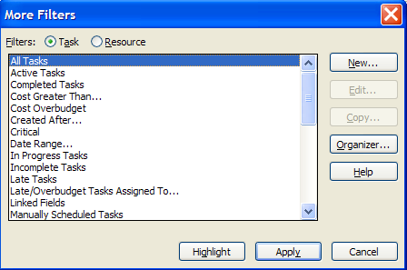

Another option accessable through this dialog box is to use the Highlight filter.   
When the Highlight filter is applied all of the data remains visible in the view and filtered data is displayed in blue. Below the same Milestone filter was applied as above requesting the Highlight option. The Highlight filter is removed in the same way as a regular filter is removed.

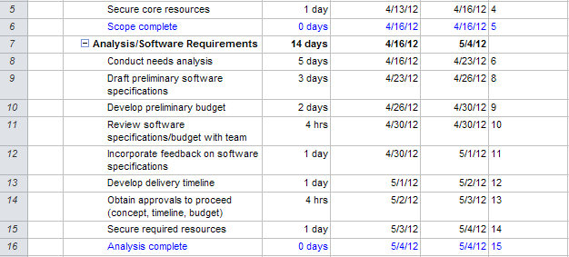

The Highlight filter may also be applied from the View bar as shown below:

* **View 🡪 Highlight 🡪 Select a filter**

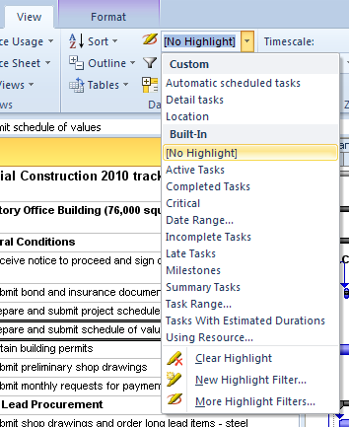

The Autofilter allows filtering of a specific column or multiple columns of data. The column used to filter the table must be visible in the table when using Autofilter. Autofilter cannot be applied to Project 2010 standard project reports or exports of data.

To turn on the Autofilter:

* **View 🡪 Filter 🡪 Display Autofilter**

A down arrow will appear when Autofilter is turned on.

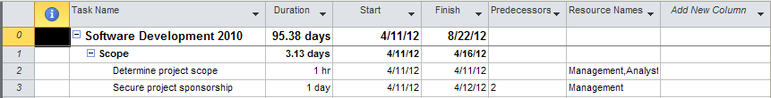

To activate Autofilter:

* Click the down arrow for the column
* Select a value

Below illustrates the options of available when using the Autofilter to filter the Resource Name column in the Task Entry table. Every column will contain unique data and the Filters offered will change with the columns selected:

Multiple options become available:

* Column A-Z sort
* Column Z-A sort
* Group on this field
* Filters

To select the Project Manager resource only:

* Click **Select All** to clear all checkboxes
* Click **Project Manager**

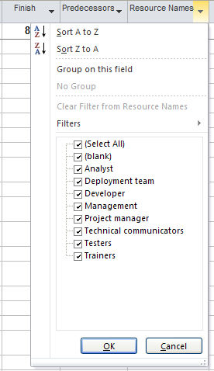

Below is the result of applying this filter. A funnel icon appears in the Resource Name column as an indicator to show which column is being used to filter the table. Note that all of the tasks in the Resource Name column contain the value Project Manager.

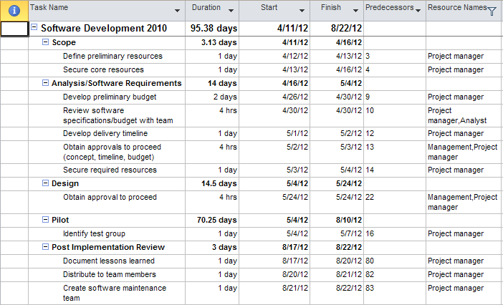

To clear the filter and restore the data to its original state:

* Click **F3**  
  OR
* Click the funnel symbol
* Clear filter from <column name>

Many filters will include summary as well as detail tasks. Summary tasks may be turned off to view detail tasks only. To turn off Summary tasks:

* **Format** 🡪uncheck the **Summary Task** checkbox

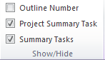

## Practice: Working with Groups and Filters



*The Practice page is where you write detailed instructions for completing work listed as Exercises.*

*Type the Exercise Title and write a brief summary what the student will be doing in the exercise. Then list your ideas what they will be doing.*

*SAMPLE*

*In this practice you will create a Project Server Authentication profile and then configure the local cache settings in Project Professional 2007.*

*Exercise 1: Create Project Server Authentication Profile*

*In this exercise you will create Project Server authentication profile to connect to the Project Web Access site.*

Perform the following exercise on the PS07 virtual machine.

1. *From the* ***Start*** *menu, click* ***All Programs*** *🡪* ***Microsoft Office*** *🡪* ***Microsoft Office Tools*** *and click* ***Microsoft Office Project Server 2007 Accounts****.*
2. *In the* ***Project Server Accounts*** *dialog box, click* ***Add****.*
3. *In the* ***Account Properties*** *dialog box, and complete the following settings and click* ***OK****.*

|  |  |
| --- | --- |
| *Setting* | *Perform the following:* |
|  | |
| *Account Name* | *Type* ***Project Server*** |
| *Project Server URL* | *Type* ***http://epm/pwa*** |
| *When connecting* | *Select* ***Use Windows user account*** |
| *Set as default account* | *Select check box* |

# Lesson 2: Understanding the Critical Path Method



Once the initial schedule has been created, a timeline for the project will begin to form. It is this timeline that will determine the end date of the project. The Critical Path is the longest path of tasks through the network of tasks for the project.

In this lesson you will learn:

1. What is the Critical Path
2. Formatting views to display the Critical Path
3. Setting option for Tolerance level for the Critical Path

## What is a Critical Path



The Critical Path is the longest path of tasks through the network of tasks for the schedule. It represents the timeline of the schedule and establishes the end date for the project. It is the minimum time that it will take to complete the project. Tasks not included in the network of tasks will not be included in critical path calculation. For a more accurate critical path calculation, all tasks should have a predecessor and a successor except the first and last tasks of a project. Checking the contents of the predecessor and successor columns to make sure all tasks have valid entries is helpful.

Any task on the critical path is known as a Critical Task. If a critical task slips, the end date of the project will be negatively affected.

Scheduling factors contributing to Critical Path calculation include:

* Relationships between tasks
* Lead and Lag time
* Duration of tasks
* Constraints
* Task Calendars
* Resource Availability
* Resource Assignments

Project 2010 will automatically recalculate the critical path each time a task is changed. The calculation is making a forward and backward pass through the schedule looking for time gaps between tasks. This time gap is called slack which is also known as float. If a task has slack, it is considered non-critical. When a task has no slack, it is considered critical. Slack can be both a positive or negative value.

Every project schedule should include float or slack in order to address contingencies. No project will run exactly as planned. Float or slack will provide the extra time needed to handle unknown problems that will arise during the execution of a project.

There are 2 types of slack calculated in Project 2010:

* Total slack is the amount of time a task can slip without affecting the end date of the project.
* Free slack is the amount of time a task can slip and affect only the successor task. If a task does not have a successor, free slack will be the same as total slack.

This type of critcal path calculation is based on tasks. Resources can also be critical within a project schedule. During the execution of the project, different resources will become critical at different points within the schedule. If a critical resource is not available at a critical point, the entire project could be affected as well as the ending date.

Frequently, during the execution of a project, a task that was not originally on the critical path will become critical. Careful tracking and monitoring of the critical path during the management of the project will help keep the project manager on track to achieve the goal of their projected end date.

**Manually scheduled tasks and critical path**

Manually scheduled tasks will be included in the critical path calculation if they have dependencies and duration. In the absence of dependencies, only tasks that push the end date of the schedule will appear on the critical path.

**TIP:** The default for Project 2010 critical path calculation is to recalculate the critical path every time a task is changed. In very large schedules, critical path recalculation can slow the schedule development process. For this reason, automatic calculation may be turned off and the calculation manually triggered when the scheduler is ready.

To turn off automatic schedule calculation:

* **File 🡪 Options 🡪 Schedule**

Calculation option

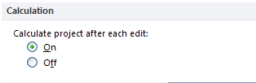

To calculate a project on demand:

* **Project 🡪 Calculate Project**

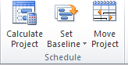

## Formatting Views to Display Critical Path



Slack is essentially scheduling breathing space for a project. The greater the slack, the more breathing space you will have to help manage problems that will occur during the performance of the project. If a schedule fails to include slack, the plan for the schedule might be unobtainable. Since projects are never performed exactly as scheduled, slack becomes essential to achieving the goal date for the project.

Each time a task is changed in Project 2010, the critical path is recalculated automatically. There is a column labeled “Critical” that contains a Yes or No value. This column is reset as a result of critical path calculation and could change as the project progresses and changes. Formatting of Gantt Charts and other views depend on the “Critical” column to determine how view formatting should appear. Many of the views are not pre-formatted to show the critical path. The formatting may be turned on as necessary.

To turn on and show the critical path formatting:

* **Task 🡪 Gantt view**
* **Format 🡪 Critical Path**

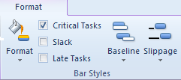

The critical path is shown as red Gantt bars and the non-critical tasks appear a blue Gantt bars.

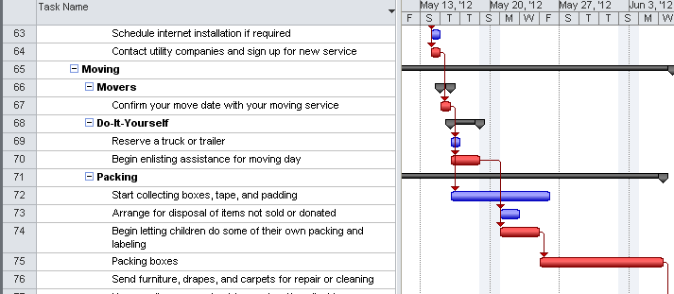

To get what is called a waterfall or tasks in sequence critical path, apply the critical filter and all non-critical tasks will be hidden. .

To filter the schedule for critical path:

* **Task 🡪 Gantt Chart view**
* **Format 🡪 Filter 🡪 Critical**

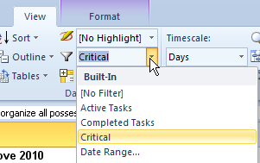

In the view below the Critical filter has been applied. All non-critical tasks have been hidden. The view is an example of a waterfall critical path.

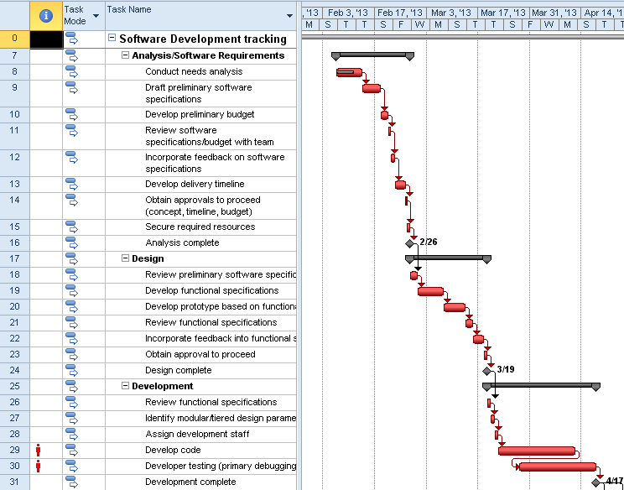

Turning off summary tasks is helpful as well

To turn off summary tasks shown on the Gantt Chart view:

* **Format 🡪 Summary Tasks**

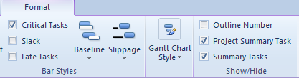

Knowing where slack in your schedule is located will help when making scheduling decisions.

To view the slack in the schedule on the Gantt Chart view:

* **Format 🡪 Slack**

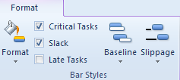

Below is a view formatted to show the schedule slack line indicators. Slack is represented by black lines extending to the right of the task Gantt bar. For clarity, in the example below, relationship arrow lines have been turned off.

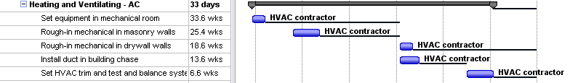

## Setting Slack Tolerance



When a task has zero slack the task is considered critical and any change in the end date for the task will negatively affect the project end date. Tasks with slack of 1 minute or more are considered non-critical. It is unlikely that 1 minute of slack is sufficient to prevent a task from moving from a non-critical to critical state.

Project 2010 provides the ability to define a per project critical task tolerance level. This setting will allow the scheduler to control what the tolerance point between critical and non-critical tasks should be. Using the total duration of the project as a guide, shorter duration projects should have lower tolerance points than longer duration projects. All cutoff points are stated in number of whole days only. The result of the critical path calculation is shown in the Total Slack column. The value in this column is used when calculating the Critical Path and determining when a non-critical task becomes critical.

To insert the Total Slack column into a table:

* **Task 🡪 Gantt Chart**
* Right click a column heading
* Select **Insert Column**
* Click the **T** key
* Select **Total Slack**

In the example below, the Total Slack column has been added to the table. Critical path formatting is turned on. All tasks in view are considered non-critical. Note the values in the total slack column show several tasks have less than 1 day of slack.

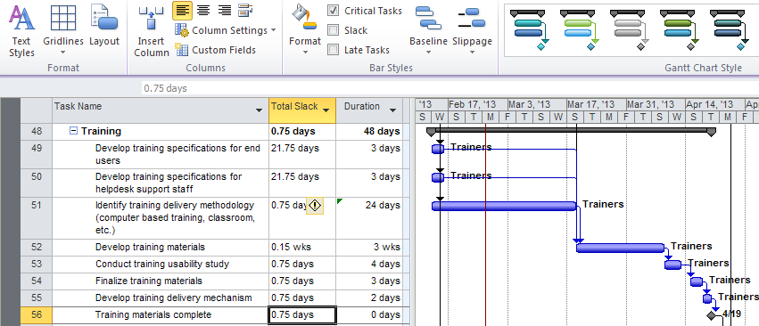

The task crtical path tolerance setting is located in the Advanced Options section. The default tolerance value is zero days. Changes to the tolerance level are in whole days only. The tolerance level setting can be applied to a single specific schedule or all schedules.

To navigate to Advanced Options:

* **File 🡪 Options 🡪 Advanced**

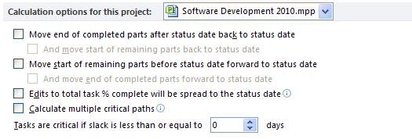

In the example below, the option has been changed to 3 days. Any task with less than 3 days of total slack will be considered critical. In the view below, several tasks have .75 days of slack and are not considered critical. Note the differences in the formatting of the critical path.

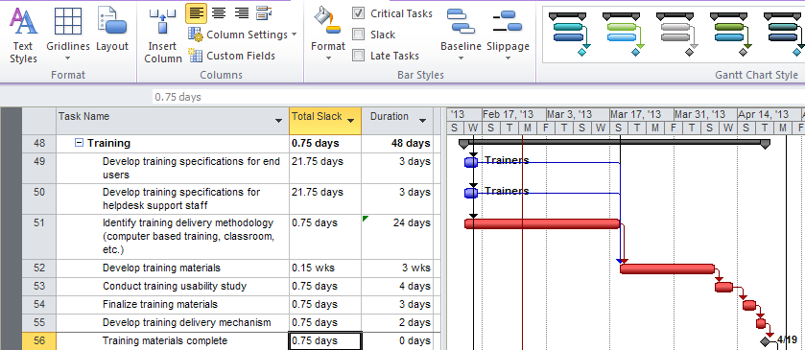

This formatting may be treated as an alert to knowing which tasks acould have impact on the ending date for the project. Once a task is flagged as critical, it will be included in filters, grouping, and reports as a critical task.

**NOTE:**  *Negative slack was discussed earlier in the module concerning constraints. Negative slack tasks will appear as critical when formatting for the critical path.*

## Crashing the Critical Path



Once you have displayed the critical path, you will have a better understanding of the specific tasks which are driving the ending date of your project schedule. Project Managers are usually asked to cut time out of the project schedule to shorten the critical path or length of the project. Since the crtical path is determining the project length, cutting time from the critical tasks will affect the project ending date. Cutting time out of the timeline for the project is known as Crashing the Schedule. When crashing the schedule, automatic project calculation is preferred because the timeline will actively change with each task change.

Below are a few suggestions which could be applied to crtical tasks to help shorten the critical path.

* Create as many parallel paths as possible. Changing task relationships to start-to-start or finish-to-finish will shorten the critical path. Beware that you may need more resources which could also in turn increase cost.
* Add as much realistic lead time as possible. Additional resources may be necessary.
* Increase working time on resource calendars. When resources are working longer hours, the work should be completed sooner.
* Remove as many constraints as possible.
* Move critical resources from non-critical tasks to critical tasks. The more experienced resources can usually accomplish the work faster and with less re-work and risk.
* Group tasks by duration as shown in this module. The longest tasks have more duration and present more opportunity to save time.
* Take long tasks and break them into smaller tasks. Try to put the smaller tasks in parallel and assign non-critical resources.
* Add evenings and weekends to gain more working time
* Question whether all tasks are really necessary and within project scope? Delete or inactivate (see below) unnecessary tasks
* Question whether the assignments are correct? Are the right people assigned to the correct amount of work? Finding errors and correcting them might reduce project time.
* Check that predecessors and successors are correct and appropriate. Blanks in the Predecessors and Successors columns indicate a missing relationship. Show all subtasks, turn off summary tasks and use the autofilter to filter for blanks. F3 to remove the filter.
* Check the Total Slack column. If the amount of Total Slack is large, there is a possibility the task is missing relationships.
* Don’t be afraid to try some what-if scenarios on a copy of the file.

If it is determined that a task is might not be necessary within a project schedule, Project 2010 allows the scheduler to switch a task to inactive mode. This removes the task from the critical path calculation but leaves the task in the schedule in case it can be activated again.

In the project below, the critical path is indicated in red. The project is scheduled to end on March 22.

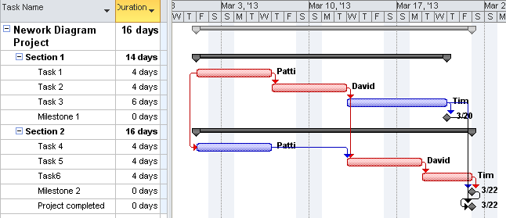

In the example below, we will inactivate Task 5.

To inactive a task:

* Click on the **task**
* **Click on Task 🡪 Inactivate**

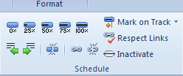

Below is the result of toggling the task to an inactive state:

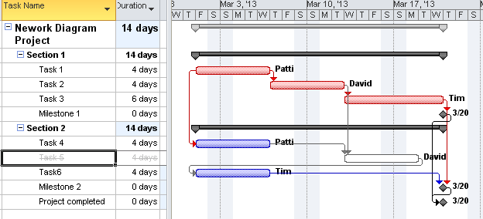

The task that was inactivated was on the critical path. The software now treats the task as if it is not there. The links are no longer valid and as a result the successor task returns to the start date of the project. The critical path has changed as well as the ending date. Since Task 5 is now inactive, the relationship between Task 4 and Task 6 was also eliminated and needs to be reestablished. The inactive task can remain in the schedule and may be activated if necessary.

## Practice: Working with the Critical Path



*The Practice page is where you write detailed instructions for completing work listed as Exercises.*

*Type the Exercise Title and write a brief summary what the student will be doing in the exercise. Then list your ideas what they will be doing.*

*SAMPLE*

*In this practice you will create a Project Server Authentication profile and then configure the local cache settings in Project Professional 2007.*

*Exercise 1: Create Project Server Authentication Profile*

*In this exercise you will create Project Server authentication profile to connect to the Project Web Access site.*

Perform the following exercise on the PS07 virtual machine.

1. *From the* ***Start*** *menu, click* ***All Programs*** *🡪* ***Microsoft Office*** *🡪* ***Microsoft Office Tools*** *and click* ***Microsoft Office Project Server 2007 Accounts****.*
2. *In the* ***Project Server Accounts*** *dialog box, click* ***Add****.*
3. *In the* ***Account Properties*** *dialog box, and complete the following settings and click* ***OK****.*

|  |  |
| --- | --- |
| *Setting* | *Perform the following:* |
|  | |
| *Account Name* | *Type* ***Project Server*** |
| *Project Server URL* | *Type* ***http://epm/pwa*** |
| *When connecting* | *Select* ***Use Windows user account*** |
| *Set as default account* | *Select check box* |

# Lesson 3: Setting a Project Baseline



The baseline of the project schedule establishes the benchmark that all progress will be measured against during the performance of the project. It will help in determining if the project is progressing on schedule and, if it is not on schedule, how far from the original scheduled plan it is.

In this lesson you will learn:

1. What is a baseline
2. Effects and benefits of setting a baseline
3. Setting a baseline
4. Updating a baseline
5. Saving multiple baselines
6. Views using baseline data

## What is a Baseline?



Using Project 2010 provides the project manager more information sooner, to make better decisions. One of the integral parts of the decision making process is being aware of where the schedule stands against its original plan. The baseline is the original plan.

After the schedule has been adjusted, discussed and negotiated with the stakeholders of the project, a schedule will be agreed upon. That orginal approved schedule will be set as the project baseline. The project baseline becomes the schedule that the metrics for the project will measure against. It is also the plan that the stakeholders are expecting the project performers to adhere to during the project.

When an event occurs to put the project off schedule, the difference between the actual performance values and the baseline values is known as the *variance*. The variance acts as the measure of how the project is performing against original plan. Monitoring variances gives the project manager more knowledge regarding the project which in turn results in better decision making to help the project get back on track.

Without a baseline, this knowledge would be lost. You would not be aware of how off track the schedule is from the original planned finish date and you would not have a finish date to manage the schedule against.

Project 2010 can also calculate Earned Value. Earned Value is a measure of how much of the value (cost) of the project have you earned at a point in time. Earned Value is based on the use of baselines and this data would be lost if a baseline was not set.

**NOTE:** *Earned value calculations are not be available for manually scheduled tasks.*

## Fields Involved in Setting a Baseline



When the baseline of the project is set, it is set for all 3 areas of the data structure. Values will be set for tasks, assignments and resources. There are technically 11 sets of baseline fields in the system.

* Baseline
* Baseline 1-10

By default the Baseline fields will be used in the project variance calculations. Baseline fields 1-10 are used for Earned Value, updated baselines or are free use fields for schedulers. If updated baselines use Baseline 1-10, the option to indicate an alternate baseline used for variance calcultions should be updated.

The following fields are used in the setting of the baseline for automatically scheduled tasks:

|  |  |
| --- | --- |
| **Field** | **Data** |
| Baseline Start | Planned start dates for tasks and assignments. |
| Baseline Finish | Planned finish dates for tasks and assignments. |
| Baseline Duration | Planned task durations. |
| Baseline Cost | Planned costs for tasks, assignments, and resources. Timephased data. |
| Baseline Work | Planned work for task, assignments, and resources. Timephased data. |
| Baseline Budget Work | Saves the budgeted work hours for work resources and units for material resources. |
| Baseline Budget Cost | Saves the budgeted costs. |

The following fields are used for manually scheduled tasks only. Although all of the above baseline fields are set when the baseline is saved, only the following fields will be used in the variance calculations for manually scheduled tasks. If manually scheduled tasks become automatically scheduled tasks the baseline values will be used for variance.

|  |  |
| --- | --- |
| **Field** | **Data** |
| Baseline estimated start 0-10 | Planned Start Date |
| Baseline estimated finish 0-10 | Planned Finish Date |
| Baseline estimated duration 0-10 | Planned Duration Date |

**NOTE:**  *Project 2010 also allows for interim plans. These plans are usually used for what-if scenairos. When an interim plan is saved, only the Start and Finish field values are copied.*

## Setting the Baseline



When setting a baseline, the following fields will be copied and held in the following fields:

|  |  |
| --- | --- |
| **Field** | **Copied to** |
| Work | Baseline Work |
| Cost | Baseline Cost |
| Duration | Baseline Duration |
| Start | Baseline Start |
| Finish | Baseline Finish |
| Start | Baseline Estimated Start |
| Finish | Baseline Estimated Finish |
| Duration | Baseline Estimated Duration |

A helpful view to check the status of the all of the above fields used (except for the estimated fields) in setting a baseline is the Project Statistics dialog box.

To view the Project Statistics dialog box:

* **Project 🡪 Project Information 🡪 Statistics**

Below is an example of the statistics box without the baseline set. Notice that the baseline fields are zero values or NA values.

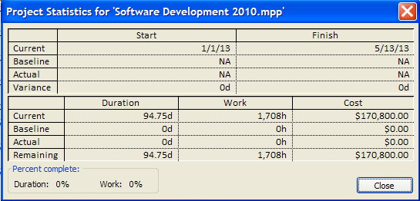

The Tracking Gantt is a good view to see the baseline. The view below shows the Tracking Gantt before the baseline is set.

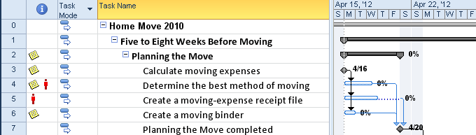

The baseline may be set for the entire project schedule or for a range of selected tasks. The range of tasks is helpful when a schedule contains several phases of a project or when tasks are added to a project schedule during project execution.

In the Set Baseline dialog box shown below, clicking the down arrow to the right of the Baseline field name will display Baseline and the other available baseline fields called Baseline 1-10. The initial baseline values should be set in the Baseline fields. The additional Baseline 1-10 fields may be used when the baseline is updated.

To set the baseline for the entire project:

* **Project 🡪 Set Baseline 🡪 Set Baseline**
* Select **Options**
* Click **OK**

NOTE: *Baselines may also be saved by ranges of selected tasks.*

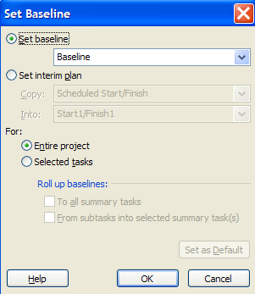

The saved baseline values are reflected in the Project Statistics box below:

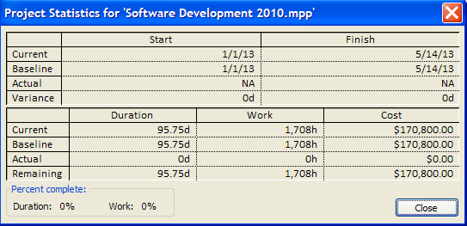

Below is a view of the Tracking Gantt with the baseline set. The baseline is represented as a grey bar under the task bars on the Tracking Gantt Chart.

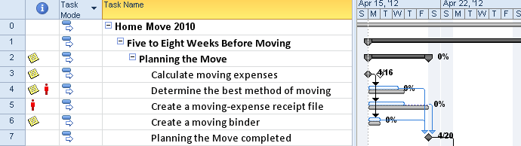

## Updating a Baseline



When approved changes are made to the schedule, the changes might result in a change to the baseline. Each organization should have a policy in place as to when or how baselines should be updated. Baselines, at times, are misunderstood by project schedulers and organizations should clarify their policies and intended usage. Management should be aware of when a baseline is reset.

Baselines may be updated to overwrite the existing Baseline fields or the updated baseline may be set using one of the Baseline 1-10 fields. If the updated baseline using the Baseline 1-10 fields will become the baseline used for variance calculations, an option must be set to indicate this change. The Gantt chart views are configured to display only the Baseline field values. If a set of the Baseline1-10 fields is used as the updated Baseline, the views should be altered to show the desired baseline fields.

In the example below changes to current schedule values were made and a new baseline will be set using the Baseline1 fields. The original baseline field values will not be altered. The steps to make this change are:

* Set the baseline to the Baseline1 fields.
* Change the option to indicate which baseline should be used for the variance calculation.
* Change a Gantt Chart View to display Baseline1 fields.

To set the baseline value into the Baseline1 fields:

1. **Project 🡪 Set Baseline 🡪 Set Baseline**
2. Set Baseline – Baseline 1
3. For: Entire Project
4. Click **OK**

The field values discussed in the last lesson will be copied to the Baseline1 set of baseline fields.

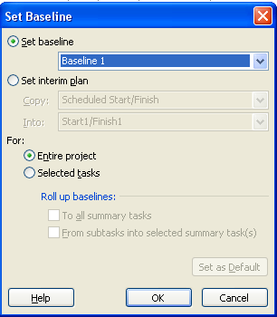

To select the baseline that will be used for the current baseline and for variance calculations:

* File 🡪 Options 🡪 Advanced 🡪 Earned Value option for this project:
* Select Baseline 1
* Click OK to close the box

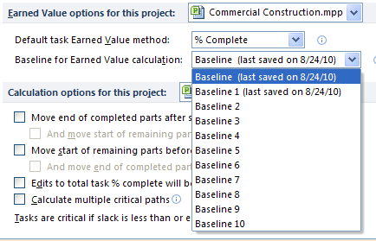

To view Baseline1 on a Gantt Chart View:

* Display a Gantt Chart View
* Format 🡪 Baseline 🡪 Baseline1

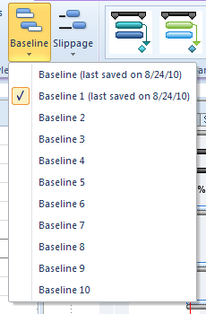

The Variance Table and Gantt Chart View using the **Baseline** field values are displayed below. Baseline Start and Baseline Finish display for Baseline values:

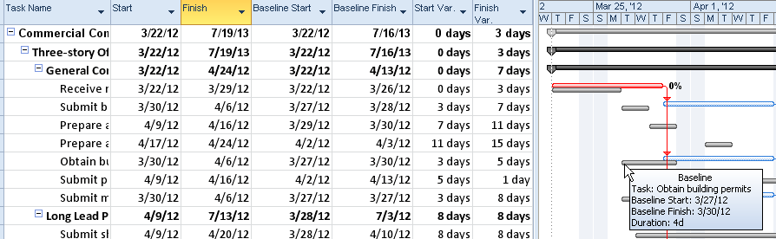

Changes in the schedule were made and the baseline was set using the Baseline1 fields. The Variance Table and Gantt Chart View using the Baseline1 field values are displayed below. Note the changes to the Start and Finish Variances and Gantt bars. Baseline1 Start and Baseline1 Finish are used to display the baseline dates:

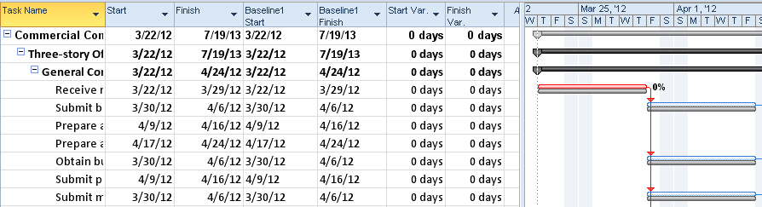

NOTE: Once it is determined that an existing baseline should be updated, all tracking information should be updated first. Updating tracking data or the actual work that was performed will be discussed in the next module. If baselines are updated to the same baseline fields for tasks that include tracking data, the baseline on those tasks will be overwritten with the new baseline values. Since the tracked tasks were completed based on the original baseline values, care should be taken to determine if those tasks should have their baselines overwritten or if the original values should remain.

## Views Using Baseline Data



Project 2010 provides many different ways to view the project baseline. Different views will display different data. The type of data requested by stakeholders should be considered when deciding which views and reports will best communcate the status of the project.

Tracking Gantt is a Gantt chart formatted to show the baseline as well as tracking data. This view shows project progress and compares baseline v current schedule. More usage for the Tracking Gantt will be discussed in the next module when tracking is discussed. The baseline is shown as the grey bars in the view below:

* **Task 🡪 Gantt Chart 🡪 Tracking Gantt**

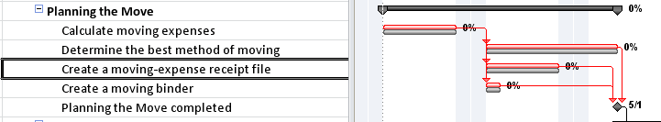

The Multiple Baselines Gantt view displays 3 possible sets of baseline fields. This view is used for comparison between the Baseline in blue and Baseline 1 fields in red. An optional 3rd baseline using Baseline 2 fields would appear in green if data was updated to the Baseline2 fields. Pointing with your mouse pointer at any of the Gantt bars will display more explanation regarding the detail of Gantt bars.

To view multiple baselines:

* **Task 🡪 Gantt Chart 🡪 More Views 🡪 Multiple Baseline Gantt**

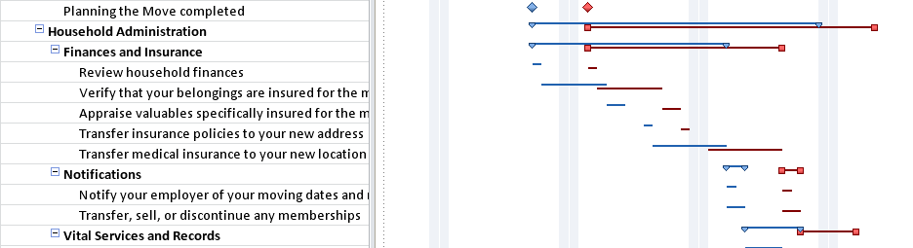

Baseline fields may be added to any Gantt chart view. In the view below, the Gantt chart displays only the current project schedule (Start and Finish fields) as red bars representing the critical path.

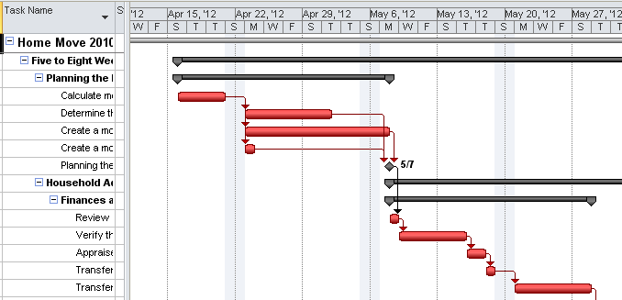

To add Baseline Gantt bars to any Gantt view:

* **Display a Gantt Chart View**
* **Format 🡪 Baseline 🡪 Select Baseline field value for display**

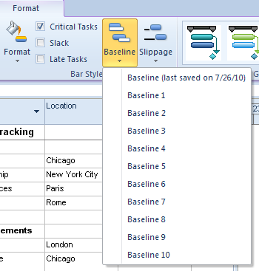

The result of adding the Baseline field is shown below. The baseline is represented as grey bars:

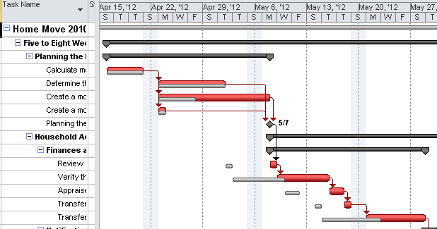

Baseline field values are also be included in many tables:

**Task tables**:

* Work
* Cost
* Variance
* Baseline
* Export

**Resource tables**:

* Work
* Cost
* Export

Baseline fields may also be added to the Task Usage and Resource Usage views as needed. These views will display time phased data for assignment.

**To add Baseline fields to the Task Usage and Resource Usage views:**

* **Task 🡪 Gantt Chart 🡪 Task Usage (or Resource Usage)**
* **Format 🡪 Usage Details**
* Click **Baseline Work**
* Click **Show** – Baseline Work will be moved to: Show these fields box on the right
* Repeat to add additional fields
* Click **OK** to close

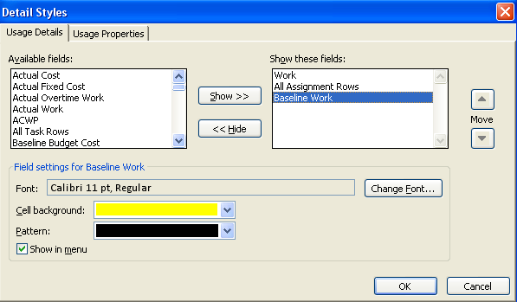

The view below is the Task Usage view showing the columns of Work and Baseline Work at the timephased level. These are values added per resource and can been seen at the per day level or other time interval.

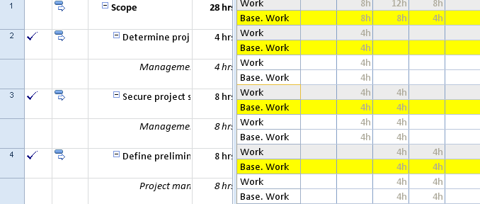

**NOTE:**  *Appendix B contains more information regarding printed reports which will include the baseline data.*

## Practice: Setting a Project Baseline



*The Practice page is where you write detailed instructions for completing work listed as Exercises.*

*Type the Exercise Title and write a brief summary what the student will be doing in the exercise. Then list your ideas what they will be doing.*

*SAMPLE*

*In this practice you will create a Project Server Authentication profile and then configure the local cache settings in Project Professional 2007.*

*Exercise 1: Create Project Server Authentication Profile*

*In this exercise you will create Project Server authentication profile to connect to the Project Web Access site.*

Perform the following exercise on the PS07 virtual machine.

1. *From the* ***Start*** *menu, click* ***All Programs*** *🡪* ***Microsoft Office*** *🡪* ***Microsoft Office Tools*** *and click* ***Microsoft Office Project Server 2007 Accounts****.*
2. *In the* ***Project Server Accounts*** *dialog box, click* ***Add****.*
3. *In the* ***Account Properties*** *dialog box, and complete the following settings and click* ***OK****.*

|  |  |
| --- | --- |
| *Setting* | *Perform the following:* |
|  | |
| *Account Name* | *Type* ***Project Server*** |
| *Project Server URL* | *Type* ***http://epm/pwa*** |
| *When connecting* | *Select* ***Use Windows user account*** |
| *Set as default account* | *Select check box* |

# Summary



Using filtering and groups will allow the project manager greater flexibility to viewing data in different ways to aid in creating reports. The critical path is the longest path of tasks through the network of tasks which will create the timeline of the project. Setting the baseline will copy the original approved schedule and enable Project 2010 to compare the orignal schedule v current schedule to help manage the project during project execution.

In this module we discussed:

1. Filtering and grouping of project data
2. Understanding the critical path
3. Steps to be taken to shorten the project timeline
4. Setting the baseline for the project